**Predicting the Ending of a Sporting Event from Traffic Data**

Nick Romano, [nromano@bellarmine.edu](mailto:nromano@bellarmine.edu)

Trevor McCormick, [tmccormick2@bellarmine.edu](mailto:tmccormick2@bellarmine.edu)

**ABSTRACT**

Up to 150 word summary of your project.

1. **INTRODUCTION**

The data set that we are working with is the Dodgers Loop Sensor Data Set from the UCI Machine Learning Repository. The Dodgers Loop Sensor Data Set came with a few files: CalIt2.events, CalIt2.data, CalIt2.names, Dodgers.events, Dodgers.data, and Dodgers.name. However, by looking over the CalIt2.names file it appears that the CalIt2.events and CalIt2.data files pertain to data about event occurrences and the traffic of people entering and existing the CalIt2 building at UCI. Since the CalIt2.events and CalIt2.data files pertain to data that is not about the Dodgers Loop Sensor data, we decided just to focus with the relevant data that belonged in the Dodgers.events, Dodgers.data, and Dodgers.name files. The Dodgers.events file is a comma separated file that contains the entries of the date, starting time, ending time, total game attendance, opponent, and result of the Los Angeles Dodgers’ home games for the 2005 MLB season. The Dodgers.data file is a comma separated file that contains entries of car count for the 101 North Freeway Glendale on ramp at 5-minute intervals from April 10, 2005, to October 1, 2005, which was just before the first Dodgers home game and last Dodgers home game. The Dodgers.name file is just a file that describes the other two files. In the Dodgers.name file, Jon Hutchins, the creator of the dataset, points out that game traffic for the Glendale on ramp begins around the end of a Dodgers game. Given the 2005 schedule information, the traffic count of 5-minute intervals, and that the fact that the Glendale on ramp picks up the game traffic around the time of a Dodgers home game ending, our goal is to try and predict whether a Dodgers home baseball game had just ended.

1. **BACKGROUND**

The Los Angeles Dodgers play their home games at Dodger Stadium in Los Angeles, California. Using censor data from the Freeway Performance Measurement System (PeMS), which is an online traffic database that gathers traffic data from sensors, Jon Hutchins was able to gather data on the count of cars on 5-minute intervals for the Glendale on ramp for the 101 North Freeway. Jon Hutchins notes in the Dodgers.name file that the Glendale on ramp to the 101 North Freeway is near Dodger Stadium to see an increase in the flow of traffic for the on ramp but is not too heavily used by the total game traffic. As mentioned earlier, this ramp sees traffic at around the end of a Dodgers game. Using Google Earth, we think that we have found the ramp that the data set is referring to. In Figure One, the red pin on the map is a on ramp for the 101 North Freeway just off Glendale Boulevard and on the right half of the figure is Dodger Stadium. With the traffic data for the Glendale on ramp, the attribute that the author was trying to predict was the presence of a Dodgers baseball game.

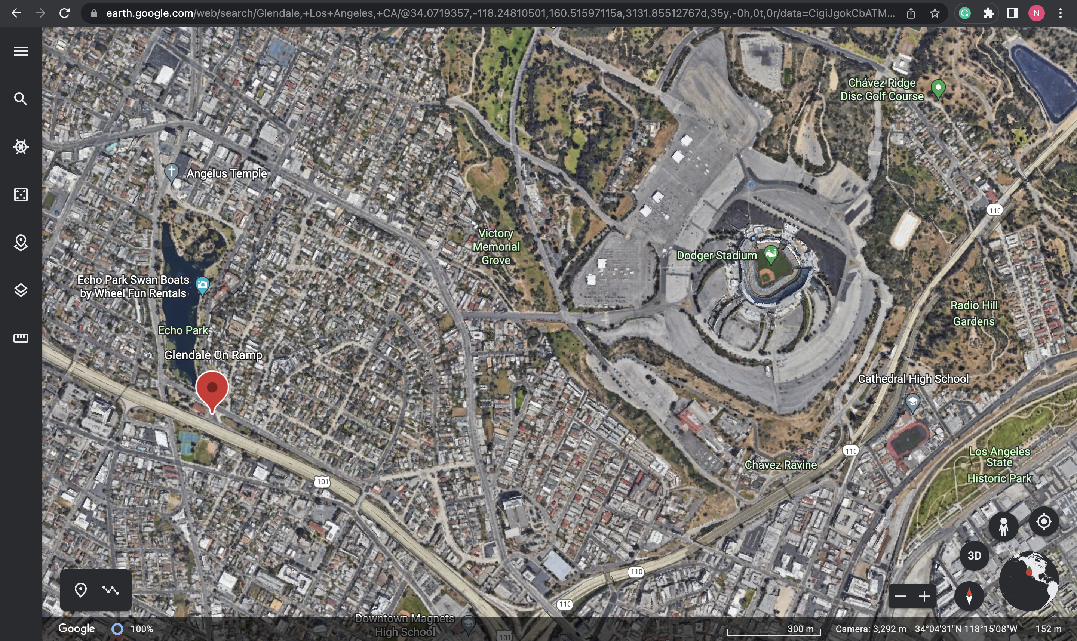

**Figure 1: The 101 North Freeway Glendale on ramp and Dodgers Stadium (Google Earth)**

1. **EXPLORATORY ANALYSIS**

**Table 1: Data Types**

|  |  |
| --- | --- |
| *Variable Name* | *Data Type* |
| Day_of_Week | Int64/Ordinal |
| Hour | Int64/Interval |
| Minute | Int64/Interval |
| Traffic_Count | Int64/Ratio |
| Game_Ended | Int64/Nominal |

1. **METHODS**
   1. *Data Preparation*
   2. *Experimental Design*

Table 2: Experiment Parameters Logistic Regression

|  |  |
| --- | --- |
| **Experiment Number** | **Parameters** |
| 1 | All four (4) raw features with 80/10/10 split for train, validate, and test |
| 2 | All four (4) raw features with 70/15/15 split for train, validate, and test |
| 3 | All four (4) raw features with 75/12.5/12.5 split for train, validate, and test |

Table 3: Experiment Parameters Random Forest

|  |  |
| --- | --- |
| **Experiment Number** | **Parameters** |
| 1 | All four (4) raw features with 80/10/10 split for train, validate, and test |
| 2 | All four (4) raw features with 80/10/10 split for train, validate, and test |
| 3 | All four (4) raw features with 70/15/15 split for train, validate, and test |
| 4 | All four (4) raw features with 70/15/15 split for train, validate, and test |

* 1. *Tools Used*

The following tools to perform the analysis: Python v3.8.8 running the Anaconda 4.12.0 environment on an Apple Macintosh computer was used for all of the analysis and implementation. In addition to the following libraries were also used: Pandas 1.2.4, Numpy 1.20.1, Matplotlib 3.3.4, Seaborn 0.11.1, and SKLearn 0.24.1.

Python v3.8.8 that was running the Anaconda 4.12 environment was chosen for the analysis since our group was more familiar with using Python than say R and RStudio. On top of that, the Pandas library was used in the analysis in order to be able to work with the data a DataFrame, clean the data

1. **RESULTS**
   1. *Classification Measures*
   2. *Discussion of Results*
   3. *Comparison of Models*
   4. *Problems Encountered*
   5. *Limitations of Implementation*
   6. *Improvements/Future Work*
2. **CONCLUSION**

**REFERENCES**

Google. (n.d.). [Google Map of Dodger Stadium and 101 North Freeway Glendale Boulevard on Ramp]. Retrieved April 26, 2022, from <https://earth.google.com/web/search/Glendale,+Los+Angeles,+CA/@34.0719357,-118.24810501,160.51597115a,3131.85512767d,35y,-0h,0t,0r/data=CigiJgokCbATMvZYCUFAEbifTHJxCEFAGcGD0S8qkF3AIenLEE0fkV3A>

*Division of Labor*

**Other directions:**

1. 10-pt, Times New Roman, 1” margins all around (if you use this template you are already set).
2. **Ensure all tables and figures are numbered appropriately and referenced in the text.** See examples above and below.

|  |  |
| --- | --- |
| **Figure 1: Comparison of X/Y from dataset (single plot) (8 pt.)** | **Figure 2: (a) Function Output (b) A against B (multiple plots) (8 pt.)** |